***SKRIPSI***

**IMPLEMENTATION OF ANDROID BILLING AT**

**WORKSHOP BARBER**



**By**

**HANSEN LORENZO**

**200060031**

**INFORMATION SYSTEMS STUDY PROGRAM**

**INSTITUT BISNIS INFORMASI TEKNOLOGI DAN BISNIS**

**Medan**

**2021**

**IMPLEMENTATION OF ANDROID BILLING AT**

**WORKSHOP BARBER**

**This *Skripsi* is done as one of the Requirements to Complete the Bachelor Degree for Information Systems Program Study**



**By**

**HANSEN LORENZO**

**200060031**

**INFORMATION SYSTEMS STUDY PROGRAM**

**INSTITUT BISNIS INFORMASI TEKNOLOGI DAN BISNIS**

**MEDAN**

**2021**

**STATEMENT OF ORIGINAL AUTHORSHIP**

Name of Candidate : Hansen Lorenzo

Student No. : 200060031

Degree : Bachelor Degree (S1)

Skripsi Title :

**IMPLEMENTATION OF ANDROID BILLING ON WORKSHOP BARBER**

I confirm that materials contained in this *Skripsi* are my own work. Where the words of others have been drawn upon, whether publishes or unpublished, due acknowledgements have been given. I also hereby declare that the materials contained in this *Skripsi* have not been published before or presented for another programme or degree in any university.

Medan, 28th September 2021

Applicant

Materai Rp. 6000

Hansen Lorenzo

200060031

|  |  |  |
| --- | --- | --- |
| **\\BILLING-SERVER\Vaultz\Logo\IT&B-small.png** | **LETTER OF APPROVAL** |  |

Student ID : 200060031

Student’s Name : Hansen Lorenzo

Skripsi Title **:**

**IMPLEMENTATION OF ANDROID BILLING AT WORKSHOP BARBER**

Date 28th September 2021

**Head of Information Systems Study Program**

**(Dr. Thamrin Kwan)**

Date 28th September 2021

***Skripsi* Advisor**

**(Dr. Thamrin Kwan)**

|  |  |  |
| --- | --- | --- |
| **\\BILLING-SERVER\Vaultz\Logo\IT&B-small.png** | **LETTER OF VALIDITY** |  |

**IMPLEMENTATION OF ANDROID BILLING AT WORKSHOP BARBER**

Is arranged and maintained by:

Student ID : 200060031

Student’s Name : Hansen Lorenzo

In front of the examiner committee on 28th September 2021 and is declared has fulfilled most of the requirement in order to obtain Bachelor Degree.

|  |  |  |
| --- | --- | --- |
| **Chief/Moderator**  **(Dr. Thamrin Kwan)** | **Approved by:**  **Examiner I**  **(Rezeki Ongsa, BA(Hons), MM)** | **Examiner II**  **(Sanif Sentosa, BSc(Hons), MM)** |

|  |
| --- |
| ***Skripsi* Advisor**  **(Dr. Thamrin Kwan)** |

**Acknowledged by,**

**Head of Information Systems Study Program**

**(Dr. Thamrin Kwan**)

**PREFACE**

First of all, the writer feels grateful to the Almighty Lord for His blessing and mercy, thus the writer has finished this *Skripsi* to fulfill one of the requirements for completing the Bachelor Degree (S1) on the Study Program of Information Systems, Institut Bisnis Informasi Teknologi dan Bisnis.

In accomplishing this writing, the writer has found a lot of difficulties either from the limitation of ability, time or strength. Therefore, the writer would truly appreciate the help of all parties for their support, guidance, instructions, insights, encouragement, motivation, advice, and suggestions so this writing can be completed. In this opportunity, the writer would like to express the greatest gratitude to:

1. Dr. Agus Susanto as the Managing Director IB IT&B.
2. Dr. Rosita as the Rector of IB IT&B.
3. Dr. Thamrin Kwan as the Head of Information Systems Study Program IB IT&B and as the *Skripsi* Advisor who has guided and given instructions and suggestions for the completion of this *Skripsi*.
4. All staffs of IB IT&B.
5. All lecturers of IB IT&B.
6. My parents and family who have given motivation and continual support in accomplishing this *Skripsi*.
7. All of my friends in IB IT&B who have motivated and shared a lot of information for accomplishing this *Skripsi*.
8. All parties who have contributed and given the help either in the form of criticism or suggestions for the accomplishment of this *Skripsi*.

Finally, the writer realizes that this writing is still far from perfection due to the limitation of ability, facilities, time and knowledge. Therefore, it would be an honor for the writer to receive any criticisms and suggestions from readers. The writer would truly appreciate the criticism and suggestions and receive it as a good input for further improvement. Hopefully, this writing will be useful for the writer himself and the readers.

Medan, 28th September 2021

The Writer

(HANSEN LORENZO)

**ABSTRAK**

**PENERAPAN PENAGIHAN TRANSAKSI BERBASIS ANDROID DI WORKSHOP BARBER**

**HANSEN LORENZO**

**200060031**

Saat ini, pengunaan seluler menjadi praktik yang lebih umum, yang berarti kebutuhan orang untuk menggunakan Android atau aplikasi seluler dipakai sebagai alat untuk mempermudah pekerjaan yang semakin dibutuhkan akhir-akhir ini.

Workshop Barber adalah usaha yang memperoleh keuntungan dari jasa potong rambut, cuci rambut, dan masker mata. Bisnis ini baru berdiri pada tanggal 8 November 2020 tahun lalu. Terletak di Jalan Garuda Sakti km 2, Jl. Melati No. Depan, Kec. Tampan, Kota Pekanbaru, Riau 28293. Usaha pangkas rambut ini melayani rata-rata 20-25 pelanggan per hari dengan bantuan lokasinya yang strategis, dan slot parkir yang luas untuk pelanggannya. Mereka bahkan berencana membuka cabang lain yang berada di tengah kota Pekanbaru, sehingga mereka membutuhkan cara yang lebih cepat untuk melakukan pelaporan dan penagihan.

Admin/kasir selalu perlu menghitung ulang laporan setiap hari/harian setiap tutup jam 9 malam kepada owner, untuk mengkalkulasi ulang keuntungan transaksi dan member customer yang telah dilayani. Secara manual mereka membutuhkan setidaknya 30 – 40 menit pemeriksaan ulang dan menuliskannya di kertas untuk keuntungan dan laporan anggota mereka. Jadi dengan aplikasi ini, setiap transaksi selesai akan langsung masuk ke database laporan, dan bisa di cek dan print ulang kapan saja

Tujuan dari tugas akhir tahun ini adalah untuk mengembangkan aplikasi perangkat lunak penagihan untuk membantu pemilik bisnis melacak laporan bisnis dan keuntungan di dalam seluler android mereka. Aplikasi transaksi Android ini akan membantu pemilik usaha untuk mempersingkat waktu untuk membuat laporan harian keuntungan mereka dan akan membantu dalam mengurangi penggunaan laporan kertas manual. Dengan menggunakan penagihan otomatis juga akan membantu mempercepat layanan pelanggan, dan melacak riwayat pelanggan.

**Kata Kunci : Kasir, Sistem Transaksi, Basis Data Awan**

**ABSTRACT**

**IMPLEMENTATION OF ANDROID BILLING AT**

**WORKSHOP BARBER**

**HANSEN LORENZO**

**200060031**

Nowadays, Mobile computing is becoming a more common practice, which means the need of people to use Android or mobile apps as their working gadget is more and more needed these days.

Workshop Barber is a business that make profit by services such as haircut, hairwash, and eyemask. This business is a new or freshly estabilished on 8th November 2020 last year. It is located on jalan Garuda Sakti km 2, Jl.Melati No.depan, Kec. Tampan, Kota Pekanbaru, Riau 28293. This barbershop business serve on average 20-25 customer a day with the help of their strategic location, and a wide parking slot for their customers. They even planned to open the other branch already in the middle of Pekanbaru city, so they need a faster way to do report and billing.

The admin / cashier always need to re calculate the report each day / daily every closing at 9PM to the owner, to cross check their billing profit and member customer that has been served. In the manual way they need at least 30 – 40 minute of cross checking and write it down in a paper for their profit and member history. So with this software everytime the billing is done / finish, it directly go to the report database, and can be checked and reprint anytime

The goal of this final year project was to develop a billing software application to help the business owner to keep track of the business report and profit inside their gadget. This Android billing application will help the business owner to cut down the time to make daily report of their profit and it will help in reducing the usage of manual paper report. By using automatic billing also will help to fasten the service of the customer, and keep track on the customer history.

**Keywords: Cashier, Billing system, Cloud Based**

# TABLE OF CONTENTS

TABLE OF CONTENTS 9

LIST OF TABLE 10

LIST OF FIGURE 10

Chapter 1 11

1.1.Background study / Reason of choosing title 11

1.2.Problem Identification 13

1.2.1.The admin / cashier still using a manual way for customer billing. 13

1.2.2.All daily report is done manually with paper every day. 13

1.3.Scope Of Study 13

1.4.Objectives 13

1.5.Benefit 13

Chapter 2 14

Theoritical background 14

2.1.Java Development Kit 14

2.2.Nox 15

2.3.MySQL 16

2.4.Android Studio 16

Chapter 3 17

Research Methodology 17

3.1 Research location 17

3.2 Research objects 17

3.3 Data Analysis 18

3.4 Data Analysis Method 18

Chapter 4 19

Result & Analysis 19

4.1 Result 19

Chapter 5 27

Conclusion & Suggestion 27

5.1 Conclusion 27

5.2 Suggestion 27

# LIST OF TABLE

Table 1 Android Version ……………..……………………………………………. 12

Table 1 Android Version ……………..……………………………………………. 13

# LIST OF FIGURE

Figure 4.1 Flowchart Beginning Application ..…………………………………….. 25

FIgure 4.2 Flowchart Home Scene ……….…………………………………………26

Figure 4.3 Flowchart Dashboard Scene ……………………………………………..27

Figure 4.4 Flowchart Report Scene ..........…………………………………………..28

Figure 4.5 Home Scene …...………….……………………………………………..29

Figure 4.6 Add New Price Scene ……..……………………………………………..29

Figure 4.7 Dashboard Scene ………….……………………………………………..30

Figure 4.8 Add New Transaction Scene ...…………………………………………..30

Figure 4.9 Confirm Payment Scene …..……………………………………………..31

Figure 4.10 Report Scene .......…………..…………………………………………..31

# CHAPTER 1

**INTRODUCTION**

## **Background study / Reason of choosing title**

Mobile computing is becoming a more common practise, which means the need of people to use Android or mobile apps as their working gadget is more and more needed these days. But before we get to the reason why the writer choose this title, let’s learn what is android and it’s history.

Android was started in October 2003 by Andy Rubin, Rich Miner, Nick Sears, and Chris White under a company called Android Inc in Palo Antom, California, before being acquired by Google in 2005. The initial goal of this platform was to developing an operating system that is more sophisticated for the performance of a digital camera. However, the existence of the global market changed the flow of Andy and his friends to bring Android Inc to change its function as a company engaged in smartphone operation system development.

November 5, 2007 was the first time Android launched a beta version that coincided with the establishment of the Open Handset Alliance or OHA. This became a momentum and was designated as Android Day. It's interesting too! Not only that, it turns out that one week after the launch of the beta version, Android launched the Software Development Kit or known as the SDK on November 12, 2007. The SDK allows users to contribute, create, and develop their own Android applications.

Android will continue to try to update its operating system in order to continue to satisfy the needs of the global market. Current technological advances are of course inseparable from technological developments that are increasingly recent. This can be seen from the version after version that Android continues to launch. The various features that Android offers have made it the king of the smart phone platform. Below is the table of Android version;

|  |  |  |
| --- | --- | --- |
| Version | Name | Release Date |
| 1.0 (API Level 1) | - | September 23, 2008 |
| 1.1 (API Level 2) | - | February 9, 2009 |
| 1.5 (API Level 3) | Cupcake | April 27, 2009 |
| 1.6 (API Level 4) | Donut | September 15, 2009 |
| 2.0 – 2.1 (API Level 5-7) | Eclair | October 26, 2009 |
| 2.2 – 2.2.3 (API Level 8) | Froyo | May 20, 2010 |
| Version | Name | Release Date |
| 2.3 – 2.3.7 (API Level 9-10) | Gingerbread | December 6, 2010 |
| 3.0 – 3.2.6 (API Level 11-13) | Honeycomb | February 22, 2011 |
| 4.0 – 4.0.4 (API Level 14-15) | Ice Cream Sandwich | October 18, 2011 |
| 4.1 – 4.3.1 (API Level 16-18) | Jelly Bean | July 9, 2012 |
| 4.4 – 4.4.4 (API Level 19) | KitKat | October 31, 2011 |
| 5.0 – 5.1.1 (API Level 21) | Lollipop | November 12, 2014 |
| 6.0 – 6.0.1 (API Level 23) | Marshmallow | October 5, 2015 |
| 7.0 (API Level 24) | Nougat | August 22, 2016 |
| 7.1.0 – 7.1.2 (API Level 25) | Nougat | October 4, 2016 |
| 8.0 (API Level 26) | Oreo | August 21, 2017 |
| 8.1 (API Level 27) | Oreo | December 5, 2017 |
| 9.0 (API Level 28) | Pie | August 6, 2018 |
| 10.0 (API Level 29) | Android 10 | September 3, 2019 |
| 11 (API Level 30) | Android 11 | September 8, 2020 |

The goal of this final year project was to develop a billing software application to help the business owner to keep track of the business report and profit inside their gadget. This Android billing application will help the business owner to cut down the time to make daily report of their profit and it will help in reducing the usage of manual paper report. By using automatic billing also will help to fasten the service of the customer, and keep track on the customer history.

Workshop Barber is a business that make profit by services such as haircut, hairwash, and eyemask. This business is a new / freshly estabilished on 8th November 2020 last year. It is located on, Jalan Garuda sakti km 2, Jl. Melati No.depan, Kec. Tampan, Kota Pekanbaru, Riau 28293. This barbershop business serve on average 20-25 customer a day with the help of their strategic location, and a wide parking slot for their customers. They even planned to open the other branch already in the middle of the Pekan Baru city, so they need a faster way to do report and billing.

## **1.2**. **Problem Identification**

### **1.2.1. The admin / cashier still using a manual way for customer billing.**

Nowadays most of the business such as cafe, restaurant, market, etc have been using software to avoid human error on counting billing of the customer and make the work flow of the staff much more faster than doing it manually by writing every bill on a piece of paper. So this software is made to help the Workshop Barber to cut down the time process of serving the customer billing and avoid / minimize the error.

### **1.2.2. All daily report is done manually with paper every day.**

The admin / cashier always need to re calculate the report each day / daily every closing at 9PM to the owner, to cross check their billing profit and member customer that has been served. In the manual way they need at least 30 – 40 minute of cross checking and write it down in a paper for their profit and member history. So with this software everytime the billing is done / finish, it directly go to the report database, and can be checked and reprint anytime

## **1.3. Scope of Study**

Due to limitation of time, ability to go directly to the Workshop barber. The writer would like to limit the study, and only focus on the implementation of Android Billing of Workshop Barber

## **1.4. Objectives**

The research will be focused on conducting an Andoid billing software to help Workshop Barber to cut down the used time of serving customer billing and daily report. And make it automatically calculate billing daily to the database report to avoid data loss on manual way of making daily reports.

## **1.5. Benefit**

The Benefit of the project is to ease user to fasten their services on billing and making daily report. Also helping the user to re print or look at their report anytime by Android application. And cut down the use of paper for report and billing to avoid the loss of report.

# CHAPTER 2

## **Theoritical background**

### **2.1. Java Development Kit**

The Java Development Kit (JDK) is a software development environment used for developing Java applications and applets. It includes the Java Runtime Environment (JRE), an interpreter/loader (java), a compiler (javac), an archiver (jar), a documentation generator (javadoc) and other tools needed in Java development. Below is the function of the tool or feature of Java Development Kit (JDK);

* **javac:** This utility is used to compile Java source code into Java bytecode.
* **rmic:** This utility creates skeletons and stubs for use in Remote Method Invocation (RMI).
* **jar:** This compression utility aggregates a multitude of files into a single Java ARchive (JAR) file. The jar utility uses a standard compression algorithm used by all of the most common zip utilities.
* **javadoc:** This utility can examine the names of classes and the methods contained within a class, as well as consume special annotations in order to create application programming interface (API) documentation for Java code.
* **wsgen:** This generates various artifacts required by Java API for XML Web Services (JAX-WS).
* **javap:** This utility disassembles class files, generating information about the methods, properties and attributes of a given compiled component.

For developers who wish to work in an integrated development environment (IDE), a JDK bundled with Netbeans can be downloaded from the Oracle website. Such IDEs speed up the development process by introducing point-and-click and drag-and-drop features for creating an application. There are different JDKs for various platforms. The supported platforms include Windows, Linux and Solaris. Mac users need a different software development kit, which includes adaptations of some tools found in the JDK.

JDK does not include support for components such as servlets, Java ServerPages (JSP) and Enterprise JavaBeans (EJB). These components are part of the Java EE platform, which is built on top of Java SE. Similarly, the JDK does not have inherent support for microdevice development with Java ME

Peripheral programming languages, such as Groovy, Clojure, Scala and Kotlin, continue to gain in popularity. These languages all run on the JDK but provide various features that overcome the limitations of the Java language. For example, Groovy provides strong scripting features. Scala and Clojure solve various scalability issues the Java program runs into. And Kotlin greatly simplifies Android application development. All of these languages run on a JVM and take advantage of the standard libraries and other features that are built into the Java platform. With over 20 years of availability, the JDK has proven itself reliable enough to withstand the most extreme environments and workloads, and with its ability to support new languages that add extra functionality over and above that of the Java language itself

### **2.2. Nox**

There are many free android emulators available on the internet but Nox is among one of the very few emulators which are reliable as well. Nox works seamlessly on windows PC to give you an amazing experience of android right on your windows. Nox app player is based on virtualization and creates a virtual environment of latest android where you can install and run your favourite android apps and games.

Nox app player has a nice and clean user interface which makes its users addicted. We strongly believe if you once start using Nox, you won’t regret at all. Most of the computers around the world are powered by Windows and that’s why we focused primarily on making an android emulator for windows and that is how Nox was made.

Nox is completely free to download and use without any hidden charges. The app has a great usability as well as most of the popular android apps and games are already available for direct downloading from inside Nox for windows. If you are a gamer then you would definitely like this emulator as it supports many third party controller devices including joysticks, etc and support to more.

The minimum requirements of nox app player:

* Minimun Windows XP SP3 to the latest Windows 10
* At least dual core processor of Intel or AMD
* Minimum RAM of 1.5GB RAM but recommend to have 4 GB
* 1GB available storage for installation path and 1.5 GB for hard drive space

Nox App Player’s operating system is based on Android 4.4.2, which lets you use practically any app within Android’s extensive catalog. Additionally, this version is possibly one of the most popular and widely used programs out there today, so tons of users are already familiar with it. Nox App Player unique feature provide its user to create or customize controls in any app with a very simle and intuitive way, in less than a minute we can configure our keyboard to adapt its button to any Android game. And lastly, Nox App Player is incompatible with BitDefender.

### **2.3 MySQL**

MySQL is a SQL database management system software or DBMS that is multithreaded, multi-user, with over 6 million installations worldwide. MySQL AB makes MySQL available as free software under the GNU General Public License (GPL), but they also sell the software under a commercial license for cases where its use is incompatible with the use of the GPL.

Unlike PHP or Apache which are software that developed by the general community, and copyright for the source code belongs to their respective authors, MySQL is owned and sponsored by a Swedish commercial company, MySQL AB. MySQL AB holds the full copyright to almost all of its source code. The two Swedes and one Finn who founded MySQL AB are: David Axmark, Allan Larsson, and Michael "Monty" Widenius.

### **2.4. Android Studio**

You already know what Android is, experience its various advanced features, and know the various types of free and paid applications on the Play Store. Android studio is an Integrated Development Environment (IDE) or in other words, an official integrated development environment that is designed specifically for the development of the Google Android operating system. This application, built on a device called **JetBrains' IntelliJ IDEA**. It can be said that, Android Studio is the replacement for **Eclipse Android Development Tools** or native Android application development

Of course, you already know that Android is an open source platform that is free for anyone to develop. Well, this is ADT as the main IDE in the software that you will use to design your own Android application. Android Studio was launched on May 16, 2013 at the Google 1/0 conference which at that time was still in the pilot version of Access Preview stage. Until finally there was a stable version 3.0 which was released in mid-October 2017 and made it the best-selling software among young developers. Including you, right? This application can be used on various operating systems, such as Windows, Linux, and macOS. It is not difficult for a beginner to learn the interface of Android Studio. There are two ways to work on a project. The first way is to use drag and drop and the other is by writing the source code on the worksheet.

# CHAPTER 3

## **Research Methodology**

### **3.1 Research location**

In this development, the developer will conduct research at **Workshop Barber** that is located on, Jalan Garuda sakti km 2, Jl. Melati No.depan, Kec. Tampan, Kota Pekanbaru, Riau 28293. This barbershop business is a freshly estabilished on 8th November 2020 last year.

### **3.2 Research objects**

The objects / Apps used for this development are;

* **Android smartphone** with Jelly Bean (4,2) OS or higher.
* **Java JDK (SE Development Kit)**: a special software that functions to perform processing at the management level of a Java application
* **Nox Emulator**: used for running processes or often referred to as debugging. The emulator functions to replace the device function in running the application for the first time. The emulator will display the phone screen on your computer. However, don't be surprised if the computer you use will become less responsive, aka slow. This is due to the fairly large memory usage. Unless your computer has a large RAM range of four and above.
* **MySQL**: a software product with the primary function of storing and retrieving data as requested by other software applications which the database later will be stored.
* **Android Studio**: acts as an IDE (Integrated Development Environment), which is an integrated developer tool specifically designed to develop the Google Android operating system. The Android Software Development Kit (SDK) is a kit that developers can use to develop Android-based applications. In it there are several tools for developing applications, such as the debugger process, software libraries, emulators, documentation, sample code and tutorials.

### **3.3 Data Analysis**

The developer collecting the primary data by doing an online meeting call with the business owner. The developer directly record the problem or ineffective flow of work in the business hour. First, the time consumed and human error at counting customer billing when there are so much people waiting at payment queue. Second, the process of recalculate profit and report each day taking a longer time with manually writing report.

### **3.4 Data Analysis Method**

The method of conducting this development is a case study whereas the developer does not apply hypothesis. The data acquired from the Business owner is analyze and compare with theoretical background. In this research, the developer attempts to find out the reason why the business have an inefficient time to service customers and making daily report.

The developer will use several steps to analyze the data:

1. How do the workflow of the staff serving customer from start to finish
2. What data needed to make a daily report
3. Implement the Android billing to the Workshop Barber
4. Make conclusion and give recommendation and limitation of doing the development.

# CHAPTER 4

## **Result & Analysis**

### **Result**

* + 1. **System Diagram**

**Figure 4.1** Flowchart Beginning Application



In this scene first the system show menu, if user choose Home, the scene will continue to Home Scene, if user choose Dashboard, the scene will continue to Dashboard Scene, if user choose Report, the scene will continue to Report Scene, if user choose close, the apps will closed.

**Figure 4.2** Flowchart Home Scene



In Home Scene, the first time application show the list price of hair cut, if user want to add new hair cut, user choose add new, appear dialog to adding new price list, after entry the name and price, user just click save.

If User want to edit the list price, user click the list and system show dialog, the user can edit the price and name, and click save button.

After editing or adding, the user can back to Main Menu.

**Figure 4.3** Flowchart Dashboard Scene



In Dashboard Scene, the first time application show the list pending transaction, if user want to add new transaction, user choose add new, appear dialog to adding new transaction list, after entry the name, user just click save.

If User want to make payment, user click the list and system show dialog, the user can confirm payment, and click save button.

After editing or payment, the user can back to Main Menu.

**Figure 4.4** Flowchart Report Scene



In Report Scene, the first time application show the list done transaction which transaction after get payment in dashboard scene, After shown list done transaction, the user can back to Main Menu.

* + 1. **Design**

**Figure 4.5** Home Scene

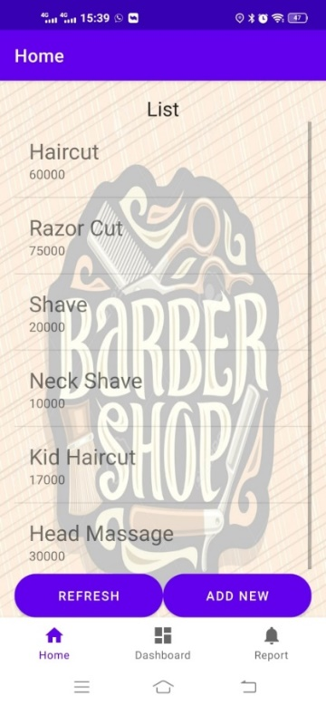

The design in the scene show the list price of cut hair.

**Figure 4.6** Add New Price Scene

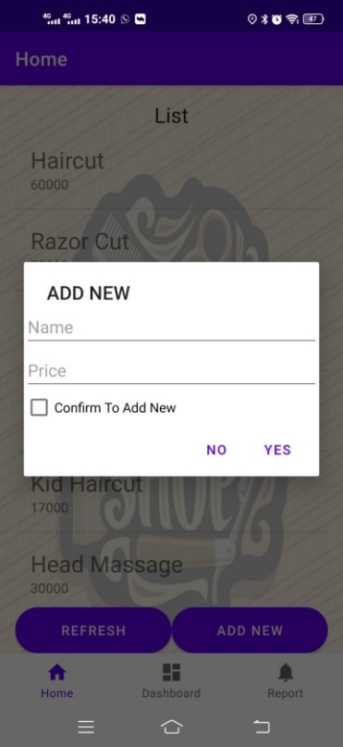

The design in the scene show how to add new price hair cut.

**Figure 4.7** Dashboard Scene

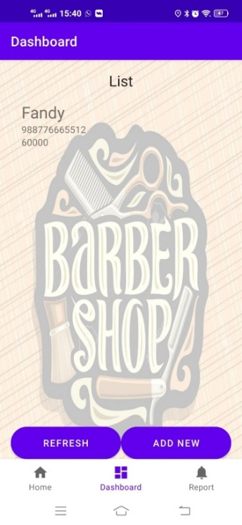

The design in the scene show the list of pending transaction.

**Figure 4.8** Add New Transaction Scene

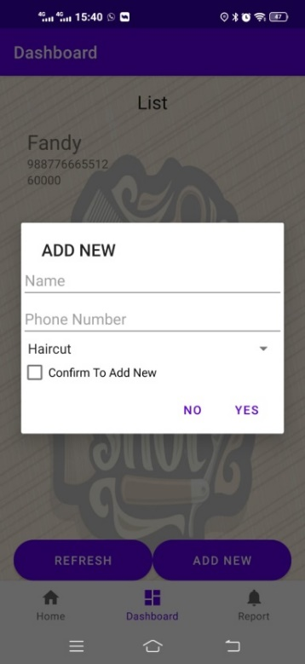

The design in the scene show how to add new transaction.

**Figure 4.9** Confirm Payment Scene

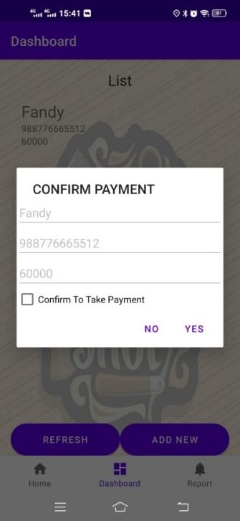

The design in the scene show how to confirm payment.

**Figure 4.10** Report Scene

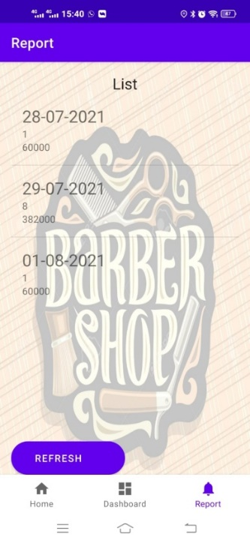

The design in the scene show list of finished transaction.

* 1. **Analysis and Discussion**
     1. **Analysis**

Analysis can be used to identify a problem for a system requirement. The result used to help analysis user needs and system requirement. The purpose of this project is the writer want to introduce android billing to make cashier operation faster and efficient.

* + 1. **Discussion**

Application testing is done by testing functionality and testing to users. Functionality testing is done to find out errors when using the application. Meanwhile, user testing is carried out to determine the suitability of the application to the needs of users in the field.

The functionality that writer testing is:

1. Checking price list, this function is to input list of the service price inside application
2. Checking pending transaction list, this function is to make pending list of transaction into the application.
3. Checking finished transaction list, this function is to make finished service list of transaction into the application
4. Event system, to get information transaction to application.

# CHAPTER 5

**CONCLUSION AND SUGGESTION**

### **5.1 Conclusion**

After finishing the research about the application. Writer can conclude that, android billing can help the user to add new price, add transaction, and see the report about transaction that happened daily on the barber shop business hour by application. the application can be access from mobile device so the user can make the process more efficient and fast.

### **Suggestion**

Based on the conclusion above, the writer would like to give a suggestion to Workshop Barber. Workshop Barber have to start using this android billing system so the percentage of losing report will be more lower than using paper for daily report, it will even help Workshop Barber to do process more efficient than the traditional way.